SCHOOL COUNCIL MINUTES
ÉCOLE CATHOLIQUE CATHÉDRALE
Wednesday, September 13, 2023
Meeting: 6:30 p.m. HYBRID

In attendance: Shelleen Lamoureux, Jacquie Whyman, Nadia Gundert, Stephanie Pettis, Ted Splinter, Emmad Hurd, Sherrie MacLean, Sandra Valente, Laura Gowsell, Christine Ferguson, Marisa Lavoratore, Laren Chrichton-Cadeau. Jessica Pudwell, Carolyn McIntyire Smith, Shauna Patel, Susanne Naoum, Chantal Courneyea, Laurie, Day, Tammy Hulton, Lisa McCarthy, Jennifer Jenkins, Cassandra Brooks, Cynthia Egbunonu
Regrets: Sarah Stanley

Call to Order - 6:38pm

Opening Prayer - Tammy

Elections - led by Tammy

Elected Positions:
Chair - Emma Hurd; 1. Nadia, 2. Christine
Co-Chair - Nadia Gundert; 1. Amy, 2. Emma
Treasurer - Jacqui Whyman; 1. Karen, 2. Sherrie
Secretary - Jessica Pudwell; 1. Jacqui, 2. Nadia

Other Positions:
Communications - Shelleen Lamoreaux and Marisa Lavoratore
Hot Lunch - Shelleen Lamoreaux (managing orders), Emma Hurd (lead for hand out Main campus), John and Helen Chapman (leads for hand out at EYC)
Events - Karen Chrichton-Cadeau
Fundraising - Christine Ferguson
Goodwill - Lisa McCarthy
Caring and Safe Schools Representative - Jenn Jenkins
OAPCE Rep - Christine Ferguson and Jacqui Whyman
Grants Coordinator - Amy White

Approval of Tonight’s Agenda
- Additions
  - Best Buy Grant
  - Events Discussion
  - Liturgy vs. Mass
  - WhatsApp
- Approval; 1. Jacqui Whyman, 2. Emma Hurd

Approval of June’s Agenda
- No concerns raised
- Approval; 1. Nadia Gundert, 2. Emma Hurd

Principal’s Report
- See appendix with presentation from Tammy
- Discussion of potential fundraising - Sparks Fly stationary bikes are desired for primary classes at main campus. They are $835 per bike.

Teacher’s Report
- Teacher Reps: Laura Gowsell (main) and Ted Splinter (EYC)
- Nothing to report, the first weeks have gone well.
- Tasked with obtaining a wish list for programming and/or fundraising from the other staff and reporting back at the next meeting.

Financial Report
- Report by Jacqui Whyman
- Opening and Closing balance: $7,055.30
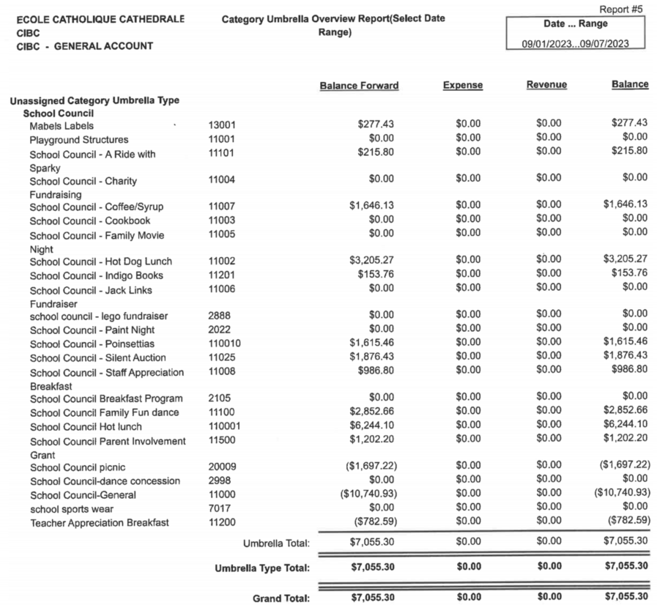

New Business
- Open house
  - Will run at EYC and Main, with food only be served at main
  - This will be clarified with the EYC families so they know they are invited to the main as well!
  - Budget: $500 total, half provided by school and half by council
    - 1. Sherrie, 2. Amy
  - Date - Sept. 21
  - Council will send Tammy our contacts for sourcing hot dogs
- Hot lunch/hot dog day
  - Discussion regarding the need to update the lunch options provided so that they are in line with the healthy schools rules
  - Based on discussion, consensus was to remain with Paradiso given that they have other options and that they offer pricing that is accessible to most families
  - Consensus to keep pizza as a weekly option as it provides vegetarian, gluten free and dairy free options
  - Coordinators will explore the other options and they will be trialed to see what is popular
  - Motion for council to fund up to 20 pay-it-forward students per month; 1. Jessica. 2. Emma
  - Start date will be September 28th, orders will close the week ahead of time
  - Will explore the ability to send reminders for orders
- Halloween Family dance
  - Decision to hold the dance on October 26th
  - Discussion regarding what will be included; consensus to have a bake sale and raffle (no silent auction)
    - Tammy indicated that a separate cash float for both was reasonable
    - Call for items to be included in the raffle will go out, number of raffle items will be kept to a reasonable amount
  - Ticketing was discussion, consensus to charge $10 per family
    - On SchoolCash we will include a field to include number of family members attending so that we can ensure we do not exceed capacity
  - All students must be accompanied by a responsible adult, this is a non-chaperoned event. Students who come without an adult will not be admitted
  - A sign up sheet for volunteers will be circulated
- Fundraising
  - Discussion regarding fall fundraiser; in the spring it was decided that the coffee fundraiser would be done in the fall, consensus was that this is a good plan
  - Committee for planning was assembled: Christine, Emma, Jessica, Sherrie
  - The committee will independently review options and come back to council with a plan for approval
  - Other potential options identified were Christmas planters/wreaths and Purdy’s chocolates
- School safety at main campus
  - Update from Tammy regarding safety items in place, which include cameras, locked entrances, fencing and yard monitors
  - The incident which occurred was all captured on camera and the police reviewed and independently decided to share with the community at large
  - Upon review, staff and students all handled the incident appropriately
  - The board was asked to review the fencing and some areas needing repair were identified
  - They are also going to install privacy fabric
  - Repairs and fabric should be done in the coming weeks
- Childcare for meetings
  - Consensu was to provide a hybrid option in lieu of childcare
- Grade/class splitting
  - Tammy reviewed the proportion of split classes and our school is in line with other schools in the board
  - Class splitting is done for a variety of reasons including social dynamics and to respect class caps
  - Tammy indicated that there is no evidence that class splitting is detrimental to learning
  - The educator will teach all students to the appropriate grade
- Bullying Policy
  - Tammy reviewed the general approach when bullying does occur
  - It is on a case-by-case basis and dealt with in an escalating manner
  - Tammy indicated that school culture is a priority for her in the first few months and she is actively addressing issues that she sees
  - Moving forward individual concerns should be directed to school admin
- Best Buy Grant
  - Amy will take review and report back to council
- Events Discussion
  - Details for first event were discussed
  - Karen will circulate a proposal for a full year events calendar to council for review and approval at the next meeting
- Liturgy vs. Mass
  - Discussion regarding the difference between a liturgy and a mass
  - Concerns were raised lass year that students were not actually attending mass
  - This year classes have been asked to attend 1 mass per month, in addition to the school wide liturgy
  - Groups of 1-2 classes will attend the regular noon mass
- WhatsApp
  - There was a reminder to keep WhatsApp chatter to official council business such as motions
  - If desired, a social chat can be created

Goodwill Report
- Nothing to report so far
Plans for Future Meetings
- Consensus was to continue with the hybrid format
- Online members reported good audio, external speakers will be purchased so that audio can be two-way without feedback for the next meeting
- Meetings will continue monthly and be on the 2nd Wednesday of the month - unless a motion to cancel or modify is brought forward
Adjournment @ 9:08pm
- 1. Amy, 2. Nadia

